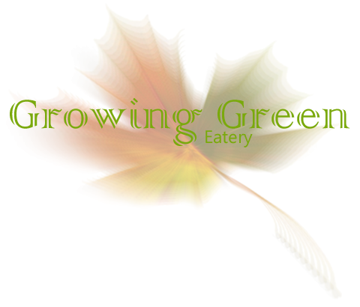

|  |  |
| --- | --- |
|  | |
| Appetizers | |
| Fried green beans | $4.50 |
| Bruschetta | $5.99 |
| Home grown vegetable platter (family size) | $11.00 |
| Stuffed mushrooms | $6.20 |
| Fried mozzarella | $6.20 |
| Entrées | |
| Filet mignon with garlic mashed potatoes | $21.99 |
| Baked chicken with cranberry glaze and rice pilaf | $15.00 |
| Penne alfredo with fresh herbs and sun dried tomatoes | $14.75 |
| Fresh garden salad with choice of dressing (add chicken + $2.00) | $7.99 |
| Baked salmon with vegetable stir-fry | $17.50 |
| Veggie burger with sweet potato fries | $12.50 |
| Kids Menu (Children under 12, comes with choice of ice cream, pudding, or jello) | |
| Chicken tenders with choice of regular or sweet potato fries | $6.00 |
| Grilled cheese sandwich with tomato | $5.50 |
| Macaroni and cheese with choice of vegetable | $5.50 |
| Spaghetti and Meatballs | $6.00 |
| Dessert | |
| Crème brulee | $4.50 |
| Cheese cake with choice of fresh fruit | $3.99 |
| Fresh Fruit Platter | $3.20 |
| Pumpkin pie with home-made whipped cream | $3.99 |